Don’t Forget our Author Visit

Dear Parents,
Just wanted to remind you that on___________________________________
we will be welcoming award-winning, children's book author, Darleen Bailey
Beard who will give an inspiring talk about following your dreams and how she
began following her dream to become a writer when she was only ten years old
(she still has the stories she wrote with her spelling words and will show them
during her PowerPoint presentation). She'll also discuss her books, her current
works, answer questions, autograph her books, and do hands-on writing
workshops with our students, if time permits.

If you would like an autographed book(s) for your student, please circle the
book(s) you'd like to purchase.

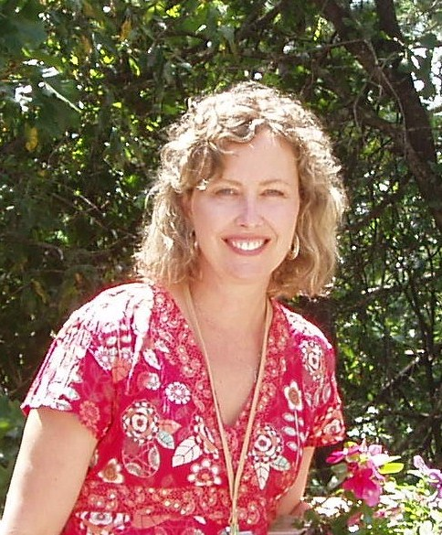
Then send this form back to school with a check made out to: ____________________________________.
Twister-- "Thrilling"-- by Publisher's Weekly.
Starred and boxed review. Beautifully illustrated 32-page picture book about the strength and determination of a brother and sister during a storm.

Paperback____________
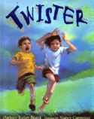
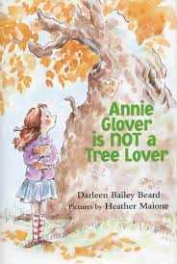
Annie Glover is NOT a
Tree Lover -- Winner of the Green Earth Book Award. A chapter book based on a true story of an Oklahoma woman who chained herself to a tree to try to keep the tree from being cut down.

Hardback_____________

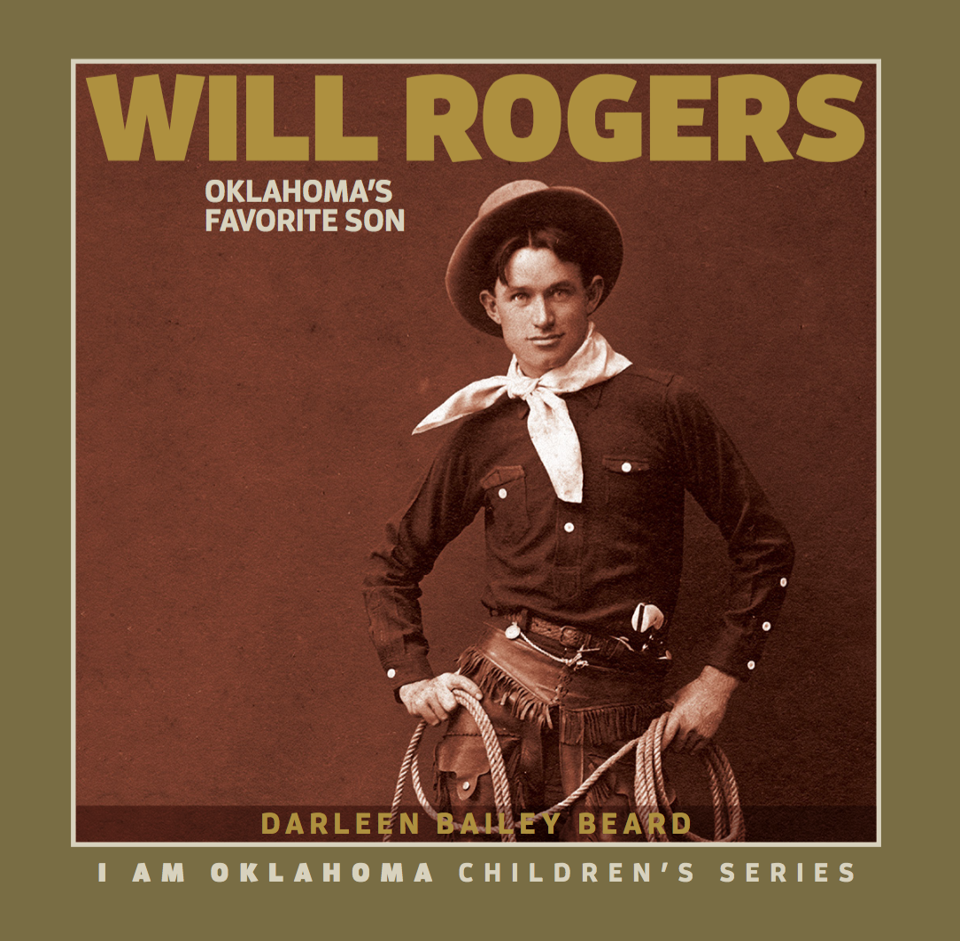
Will Rogers, Oklahoma’s Favorite Son—This nonfiction chapter book captures the life of one of Oklahoma’s most beloved personalities, complete with photos, index, sites, timeline, and more.

Hardback _____________

Hardback_______
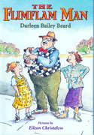
The Flimflam Man-- "A Best Book of the Year" by Bank Street College. Based on a true story in 1950, in Wetumka, OK, which led to Oklahoma’s “Sucker Day Festival”. Chapter book.

Paperback_____________
Name of student ____________________________________________________ Total number of books _______________

Name of teacher ____________________________________________________

Who the book(s) should be autographed to: _______________________________________________________________________

__________________________________________________________________________________________________________________________

