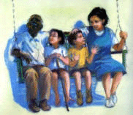 |  | 

by Darleen Bailey Beard
5 questions 1/2 point Reading level 3.5
Written by Jeanie Sisson, Red Oak Elementary, Moore OK
1. What did the children pretend their porch swing was?
A. A Throne C. A Playhouse
B. A Kite D. An Airplane
2. When mama sent the children to the cellar, where did she go?
A. Back to the house for their pet C. To get Mr. Lyle
B. To find their father D. To check on Mr. Smith next door
3. What did the children do while they were in the cellar?
A. They sang songs C. They played checkers
B. They read books D. They made wall shadows
4. Where was their father during the storm?
A. On a long vacation C. At their grandma's house
B. At work D. Helping their mother get Mr. Lyle
5. What did the children pretend were diamonds?
A. Hailstones C. Broken glass from the storm
B. Their mother's old jewelry D. Marbles they found in the yard

